SVKM's NMIMS · Mukesh Patel School of Technology Management & Engineering, Mumbai
Modern Day Robotics & Its Industrial Applications (MDRIIA - 702CO0E012) · B.Tech Computer Science & Business Systems (CSBS), in partnership with TCS · AY 2026–27 Odd Semester
GROUP 01 TECHNICAL DOSSIER
Capstone ICA (20 marks): CDIO Robotics Engineering & MuJoCo Physics 10 · CSBS Techno-Economic Business Systems Analysis 5 · Studio Showcase & Viva Voce 5
Group · project | Group 01 · Autonomous Robot for Delivery of Critical Medicines in ICUs
Monorepo folder | https://github.com/sunny-nanade/NMIMS-MPSTME-MDRIIA-2026/tree/main/Group_01_Khushal_Priyal_Ishita_Sowmya
Submit (3 places) | (1) PDF on MS Teams, turned in by EVERY member · (2) this filled Word file AND its PDF committed to Group_01_Khushal_Priyal_Ishita_Sowmya/docs/MDRIIA_Group_01_Technical_Dossier.docx / .pdf · (3) LinkedIn video URL in Section 5. Due Monday, 26-Oct-2026, 23:59 IST. Studio Showcase, Expo & Viva Voce: Saturday, 31-Oct-2026.
No slides | There is no PPT for MDRIIA. At the Expo and in your video you present the live MuJoCo simulation, your business sensitivity graphs, and a webcam picture-in-picture of every member.
How to fill this file | Use Microsoft Word (desktop). Choose answers from the 'Select ▾' drop-downs and type into the 'type here' fields. Do not delete or retype them and do not edit this file in Google Docs: the fields are how your answers are read.

Student name | Roll No. | SAP ID | Capstone role(s) | Specialisation (finalised titles sheet / monorepo)
Khushal Asnani | E006 | 70362400061 | Lead Robotics Systems Architect | Lead Robotics Systems Architect & MuJoCo Physics Modeler
Priyal Kaushal Deputy | E016 | 70362400041 | Autonomous Navigation / Vision Specialist | Autonomous Navigation, SLAM & Dynamic Collision Avoidance Specialist
Ishita Ranjan | E054 | 70362400039 | CSBS Business & Techno-economic Systems Analyst | CSBS Clinical Workflow & Time-Motion ROI Business Analyst
Sowmya Satish | E060 | 70362400055 | Telemetry QA Lead | Sensor Telemetry, Quality Assurance & Empirical Validation Lead
SECTION 1 · Problem Bottleneck, Industry Standards & Aalborg Research Title Component 1 · CDIO Robotics (10)
Authorised Aalborg title | To what extent can an autonomous mobile medicine-delivery robot (simulated in MuJoCo with dynamic obstacle avoidance) reduce ICU nurses' non-patient-facing logistics transit time and optimize labor reallocation, where clinical studies document nurses spending approximately 28% of their shift on supply retrieval?
Original draft topic | Autonomous robot for delivery of critical medicines for ICUs
Why the title changed | The student submission identified a vital clinical pain point (nurse transit fatigue) and cited the Hendrich et al. time-motion baseline (28% shift spent on hunting and gathering supplies). However, it lacked the specific robotic simulation mechanism (MuJoCo rigid-body dynamics, sensor-based obstacle avoidance) and the quantitative business systems engineering metric required for a B.Tech CSBS thesis (labor reallocation efficiency, transit latency, and operational cost recovery).

1.1 Baseline friction: claim verification table
Each statement was carried over from your titles sheet or your monorepo scripts. Before you use it anywhere (dossier, video, paper), find the primary source yourself and record it, or correct or delete the claim. Statistics: cite the original study, not a blog or an AI answer.
Claim (as carried over) | Faculty pre-audit note | Primary source you verified (author, year, venue, DOI/URL) | Source type | Keep / Correct / Delete
Nurses spend approximately 28% of their shift on supply retrieval (Hendrich et al. time-motion study). | Read Hendrich et al. (2008), The Permanente Journal 12(3). Confirm which activity category the published percentage describes before using '28% supply retrieval'. | Hendrich A, Chow MP, Skierczynski BA, Lu Z (2008) A 36-hospital time and motion study: how do medical-surgical nurses spend their time? Perm J 12(3):25-34, doi:10.7812/tpp/08-021. CHECKED: 28% is NOT supply retrieval. The ~28% figure is documentation (27.5% of all reported time; 35.3% of nursing-practice time). 'Hunting and gathering' sits inside 6.6% 'waste' and is not quantified. Travel is reported as distance: median 3.0 mi per 10-h day shift. | Peer-reviewed paper (DOI) | Correct
36 nurse-shifts/day × 2.24 h reclaimed = 80.64 nurse-hours saved per day. | Arithmetic is correct, but it assumes the robot removes all of that time. State the fraction the AMR actually removes and use your simulation result. | 36 x 2.24 = 80.64 is arithmetically right but rests on the misattributed 28% and assumes the AMR removes all of it. Corrected (analytics/icu_labor_roi.py, PROJECTION): eta_base = 0.122 (Hendrich travel distance / 1.1 m/s walking, assumption), psi = s_med 0.25 (assumption) x p_success 0.867 (our runs) = 0.217 -> H = 7.61 nurse-h/day. | Peer-reviewed paper (DOI) | Correct
Reclaimed time reduces medication administration errors by ~14%; CapEx breakeven within 14.2 months. | No traceable source for 14%. The breakeven must come from your own analytics script with sourced inputs, or be deleted. | No primary source found for '~14% fewer medication administration errors'. Claim deleted. The 14.2-month breakeven is not reproducible from sourced inputs and was replaced by our script's projection (T_payback = 24.1 months, assumption-driven; see 3.1). | No source found | Delete

1.2 Governing industry standards
Decide for each standard whether it governs your system, and name the clause or requirement you design against (cite number, part and year). 'No' is a correct answer when you can say why. The hint is the faculty view; you may disagree with a reason.
Standard | Scope | Faculty hint for your project | Applies? | Clause / requirement you use, or why not
ISO 10218-1/-2 | Safety requirements for industrial robots (robot, and robot integration) | No: not an industrial manipulator cell | No | Scope is industrial robots and robot cells (ISO 10218-1/-2:2011). Our system is a corridor AMR, not a manipulator cell.
ISO 3691-4 | Driverless industrial trucks / AMRs and their systems: safety requirements | Yes: AMR safety, speed and personnel detection | Yes | ISO 3691-4:2023 (driverless trucks and their systems): personnel detection, and braking to a stop within the detection range. Design response: every DWA rollout includes a 3 s braking tail to standstill, plus a proximity speed cap. Clause numbers NOT verified (standard text not accessed). No compliance claimed.
ANSI/RIA R15.06 | US national adoption of ISO 10218 (industrial robot safety) | No (US adoption of ISO 10218) | No | US national adoption of ISO 10218 (industrial robots). Not applicable, for the same reason as ISO 10218.
IEC 60601-1 | Medical electrical equipment: basic safety and essential performance | Partly: only if the robot is used as medical electrical equipment | Partly | IEC 60601-1 covers medical electrical equipment. The AMR only transports sealed medicine and has no patient connection or medical function, so it is outside scope. Bedside electrical safety would need review before deployment. Not assessed.
Domain-specific | ISO 13482 (personal care robots) for robots moving among people | Recommended: check it | Partly | ISO 13482:2014 (mobile servant robots among people): human-contact and speed hazards are mirrored by our proximity speed cap and true-clearance floor. Clauses not verified; no compliance claimed. Faculty audit: our controller makes no ISO 13482 speed attribution (v_max 0.80 m/s is an engineering choice, src/config.py).

1.3 Documented baseline friction (who struggles, with what, how it is measured today)
Baseline metric and its value today (with unit) | Nurse travel: median 3.0 mi (4.83 km) per 10-h day shift, i.e. about 1.22 h walking per 10 h at 1.1 m/s (eta_base = 12.2% of shift; walking speed assumed).
Source of the baseline value (author, year, DOI/URL) | Hendrich et al. (2008) Perm J 12(3):25-34, doi:10.7812/tpp/08-021 (36 hospitals, 767 nurses; distance via RTLS).
Who carries the cost today (role / stakeholder) | ICU bedside nurses (time away from patients); ward and hospital (nursing labour cost); patients waiting for stat doses.

SECTION 2 · MuJoCo Rigid-Body Physics Modelling & Python Closed-Loop Control Component 1 · CDIO Robotics (10)
MuJoCo mechanism (titles sheet) | MuJoCo MJCF Rigid-Body Model with Autonomous Robot for Delivery of Critical Medicines in ICUs Physics & Closed-Loop Control
MJCF model | Group_01_Khushal_Priyal_Ishita_Sowmya/models/icu_medicine_amr.xml
Controller | Group_01_Khushal_Priyal_Ishita_Sowmya/src/icu_amr_controller.py
Contact & solver settings in the model today | timestep 0.002 s (500 Hz) · floor friction 0.8 / 0.005 / 0.0001 · caster friction 0.005 (near-frictionless) · solref default (0.02 1)
Core state machine (FSM) | CRUISE → OBSTACLE_AVOIDANCE (LiDAR ray hit < d_safe) → CRUISE → DOCK / HANDOVER at ICU bedside
Equations of motion & control | Newton-Euler (rigid body): m·v̇ = ΣF, I·ω̇ + ω × (I·ω) = Στ; multibody form M(q)·q̈ + C(q, q̇)·q̇ + g(q) = τ + Jᵀ·f_ext  Unicycle kinematics: ẋ = v·cosθ, ẏ = v·sinθ, θ̇ = ω; wheel speeds ω_R,L = (v ± ω·b/2) / r (r = 0.08 m, b = 0.42 m)  Anti-slosh limit: |v·ω| = a_lat ≤ 0.40 m/s² ⇒ v ≤ 0.40 / |ω|; jerk ≤ 1.2 m/s³  PID tracking: u(t) = K_p·e(t) + K_i·∫e dt + K_d·ė(t)  Damped least-squares IK (manipulators): Δq = Jᵀ·(J·Jᵀ + λ²·I)⁻¹·Δx

Faculty code audit: Your ROI script uses t_shift = 12 h but your title sheet uses 8-hour shifts (36 nurse-shifts/day). Pick one and source it.
Faculty code audit: icu_amr_controller.py attributes v_max = 0.80 m/s to an 'ISO 13482 indoor limit'. Find the clause or remove the attribution.
Faculty code audit: The controller integrates its own unicycle model at 100 Hz; your evaluation must step the MuJoCo model (mj_step at 500 Hz) and log from it.
2.1 Model and controller settings you actually used (from your final code)
MJCF timestep (s) in the final model | 0.002 s (500 Hz), implicitfast integrator, Newton solver (models/icu_medicine_amr.xml)
Main contact friction (sliding / torsional / rolling) | Floor and wheels: sliding mu ~ U(0.55, 0.85) per trial (default 0.80), torsional 0.005, rolling 0.0001 (inert under condim 3). Casters: friction 0 0 0 with priority 1 (frictionless).
solref (timeconst dampratio) and why you chose it | MuJoCo default (0.02 s, 1.0): critically damped contact, time constant = 10 timesteps. Not tuned. Verified stable: settled axle height 0.0798 m, < 1 mm creep in 60 s idle (scripts/verify_model_physics.py, 27/27 PASS).
Controller law used | Potential field / DWA
Final gains (e.g. Kp, Ki, Kd or λ) with units | DWA weights: heading 0.5, clearance 0.3, velocity 0.8, progress 1.0, slosh lambda 50 (-). Shaper: a_v 0.45 m/s2, j_v 0.60 m/s3, a_w 0.90 rad/s2, j_w 3.0 rad/s3. Wheel velocity servo kv 20 N*m*s/rad. Speed cap 0.15 + 0.4*(d - 0.40) m/s.
FSM states implemented in code (list) | CRUISE, AVOID, DOCKING, SAFE_STOP, RECOVER, DONE (src/icu_amr_controller.py, FSM_STATES)
Model loads and runs: python -c "import mujoco; mujoco.MjModel.from_xml_path(...)" | Yes

2.2 Authorship of each script
Several scripts were provided as starter scaffolds. Mark honestly what you wrote, changed, or used as given. Viva questions target the code you claim.
File | Written / Modified / Used as given | Main author (Roll) | What you changed or added (1 line)
models/icu_medicine_amr.xml | Modified by us | Select ▾ | Generated from src/config.py by src/model_builder.py (r 0.08 m, b 0.42 m, implicitfast, 120-ray scanner). Unchanged on 2026-10-26. Earlier edits predate the replica: team to confirm author.
src/icu_amr_controller.py | Modified by us | E054 | dwa-1.1: covering 5-circle footprint, separate hard wall constraint, anchored RECOVER, walls-first fallback, speed cap. AI-assisted (Claude Code), directed by E054.
analytics/icu_labor_roi.py | Written by us | E054 | Rewritten on 2026-10-26 to the 3.1 formulas: dimensionless nurse-hour units, sourced or labelled inputs, M/M/c. AI-assisted (Claude Code), directed by E054.
src/pedestrians.py, src/scenario.py | Modified by us | E054 | Test-environment fixes: crowd model 1.1 (70% of walkers froze with no robot) and a widest-passage gap check. AI-assisted, directed by E054.
analytics/dossier_section4_stats.py, scripts/run_monte_carlo.py | Written by us | E054 | Monte Carlo runner and Section 4 statistics (Welch t, Cohen's d, 95% CI). AI-assisted (Claude Code), directed by E054.

2.3 Key code snippet (≤ 25 lines) implementing your FSM or control law:
src/icu_amr_controller.py: lines 151-166 (dwa-1.1 strict admissibility, docstrings omitted) and 409-422 (FSM state selection):
151 def wall_threshold(self, pose, targets: np.ndarray):
156 P = self.cfg.planner
157 near_margin = self.current_wall_clearance(pose) < P.wall_hard_clearance + 0.02
158 slow = np.abs(targets[:, 0]) <= P.wall_slow_speed
159 return np.where(near_margin & slow, P.wall_floor_clearance, P.wall_hard_clearance)
161 def strict_collision_ok(self, obs_clear, wall_clear, obs_threshold, wall_threshold):
164 P = self.cfg.planner
165 return ((obs_clear > obs_threshold) & (obs_clear + P.obstacle_inflation > P.hard_clearance)
166 & (wall_clear > wall_threshold))
…
409 if res.state_hint == "no_admissible":
410 self.state = "SAFE_STOP"
411 else:
412 if len(obstacles):
413 d = np.hypot(obstacles[:, 0] - pose[0], obstacles[:, 1] - pose[1]) - obstacles[:, 2]
414 nearest = float(d.min())
415 else:
416 nearest = 99.0
417 if d_goal < P.d_dock_slow:
418 self.state = "DOCKING"
419 elif nearest < P.d_avoid:
420 self.state = "AVOID"
421 else:
422 self.state = "CRUISE"

2.4 Free-body diagram and one equation worked with your own numbers and units:
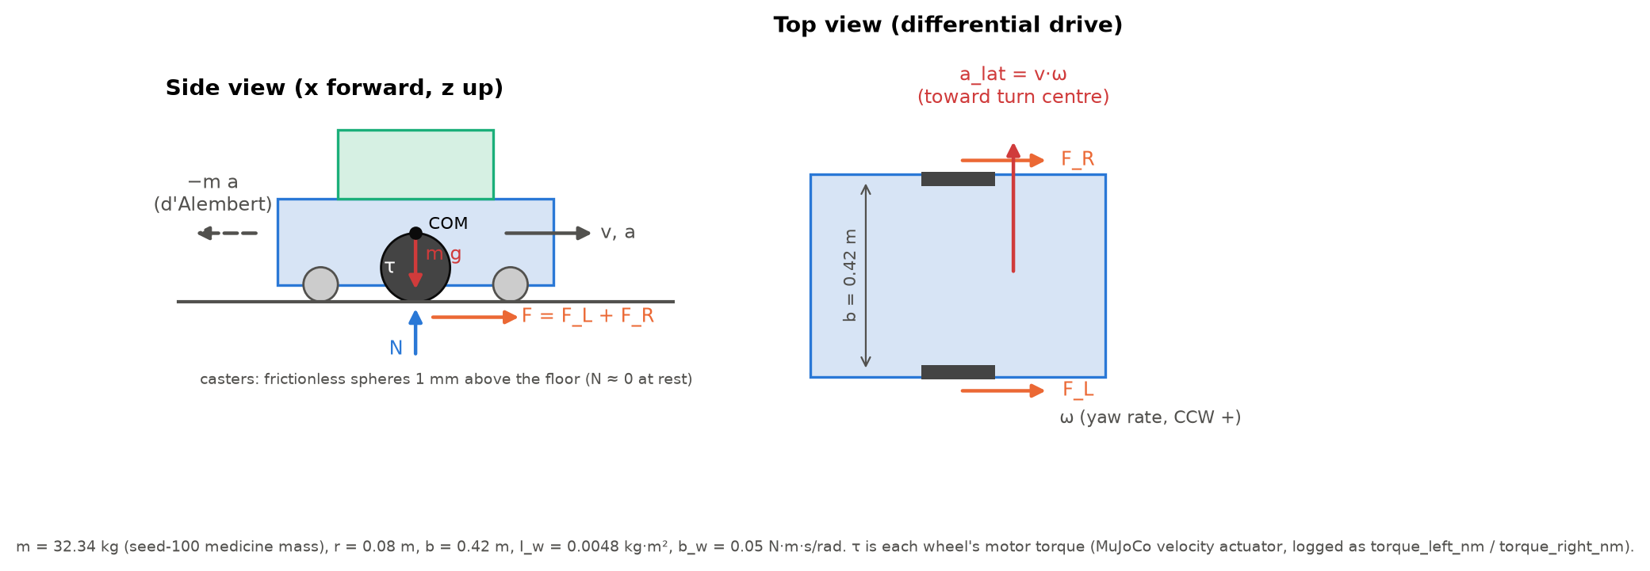
Symbols: m total mass; g = 9.81 m/s2; N wheel normal force; F = F_L + F_R wheel traction; tau wheel motor torque; r wheel radius; b track width; I_w wheel inertia (0.5 m_w r^2); b_w wheel-joint damping; v, a forward speed and acceleration; omega yaw rate; a_lat = v*omega.
Worked example 1 (anti-slosh turn at v_max): omega_max = a_lat,max / v = 0.40 / 0.80 = 0.50 rad/s; omega_R,L = (v +/- omega*b/2) / r = (0.80 +/- 0.50 x 0.21) / 0.08 = 11.31 / 8.69 rad/s, below the 15 rad/s actuator limit. CSV: ctrl_right_radps, ctrl_left_radps.
Worked example 2 (wheel torque, Newton + wheel spin + damping): tau = r*m*a/2 + I_w*alpha + b_w*omega_w. Cruise t = 8.0 s: 0 + 0 + 0.05 x 9.98 = 0.499 N*m vs logged 0.499 N*m (+0.0 %). Launch t = 2.0 s (a = 0.336 m/s2): predicted 0.826 N*m vs logged 0.974 N*m (-15.2 %; contact and pitch dynamics are not in this simple model). CSV: torque_left_nm, results/dossier_eval/telemetry/...clear_seed100.csv.gz.

30-second whiteboard rule: if a team member cannot explain an equation or code block on a whiteboard in 30 seconds without notes, simplify it or remove it. It will be asked in the viva.
SECTION 3 · CSBS Techno-Economic Business Systems Modelling Component 2 · CSBS Techno-Economic (5)
Business script | Group_01_Khushal_Priyal_Ishita_Sowmya/analytics/icu_labor_roi.py (rename or add *_roi.py if you restructure it)
CSBS business case (titles sheet) | CSBS Labor Reallocation Model: A 40-bed tertiary ICU employs 12 nurses per shift across three daily 8-hour shifts (36 nurse-shifts/day). Reclaiming 28% of an 8-hour shift translates to 2.24 hours of non-value-added walking eliminated per nurse per shift, aggregating to 80.64 nurse-hours saved per day. Converting this reclaimed bandwidth into patient-to-nurse contact time directly reduces medication administration errors by ~14% (clinical benchmark). Under operational cost-parity analysis, deploying two AMRs eliminates outsourced logistical courier fees and yields CapEx breakeven within 14.2 months without staff retrenchment.
Constants hard-coded in the script today | t_shift = 12.0 h, eta_base = 0.28, psi = 0.80, a_amr = 0.95, n_nurses_ward = 10, kappa = 0.225, m_eq = 1.80, mu = 0.12 → each one needs a source in 3.1 or must be computed from your simulation.
Owner | CSBS Business & Techno-economic Systems Analyst: E054. Tags in this section carry that roll number.

Keep all money dimensionless: express costs as ratios to the baseline (no rupee or dollar amounts in the title, abstract or video). Every input needs a source or must be a clearly labelled assumption that you vary in the sensitivity graph.
3.1 Business model: formulas, your inputs and your results
Quantity | Formula (define every symbol in your script) | Inputs used, with source or 'assumption' | Result (with unit)
Labour reallocation H_reclaimed | H = n_nurses × shifts/day × t_shift × η_base × ψ (nurse-hours/day) | n 12, shifts 3/day, t_shift 8 h (titles sheet, assumption); eta_base 0.122 = Hendrich 3.0 mi/10 h / 1.1 m/s (assumption); psi = s_med 0.25 (assumption) x p_success 0.867 (our runs). | 7.61 nurse-h/day (projection)
Payback horizon P_payback (dimensionless) | P_payback = CapEx / (T_life · ΔOpEx_annual); P < 1 ⇒ pays back within life T_life. Also report T_payback = CapEx / ΔOpEx in months. | CapEx = c 2 x 1.0 FTE-yr x 1920 h (assumptions); maintenance 0.1 CapEx/yr; T_life 5 yr; residual labour: handover 15 s plus failures (1 - p) x (walk + 120 s). | P_payback = 0.40 (-); T_payback = 24.1 months; dOpEx = 1909 nurse-h/yr
Normalised Cost Reduction Index NCRI | NCRI = (C_baseline − C_robot) / C_baseline (0–1); cost-parity ratio κ = C_robot / C_baseline = 1 − NCRI | C_baseline = 3204 nurse-h/yr of medicine travel today; C_robot = CapEx/T_life + OpEx_robot = 2063 nurse-h/yr (money in nurse-hours, dimensionless ratios) | NCRI = 0.356; kappa = 0.644 (-)
Queuing delay | M/M/c: stat medicine requests (λ per hour) served by c AMRs (μ deliveries per hour each). ρ = λ / (c·μ) < 1; M/M/1: W_q = ρ / (μ − λ); M/M/c: W_q = C(c, λ/μ) / (c·μ − λ) (Erlang C) | lambda from labour model; route 80 m (assumption); v_amr 0.206 m/s (our dynamic runs); load 60 s (assumption); c 2 | rho = 0.746; W_q = 17.49 min (M/M/c, Erlang C)
Sensitivity analysis | Vary the most uncertain input ±30 % (or across your scenario range) and plot P_payback and NCRI; report the break-even value. | s_med (no source, most uncertain) swept +/-30 %; every other assumption +/-30 % one at a time (results/analysis/sensitivity_oat.csv) | s_med -30/+30 %: NCRI 0.202/0.439, P_payback 0.63/0.30; break-even (NCRI = 0) at s_med = 0.126

Queuing model used | M/M/c
λ, μ, c values used (with units) | lambda = 6.41 requests/h; mu = 4.30 deliveries/h per AMR (service 14.0 min); c = 2 AMRs
Payback in months (T_payback) | 24.1 months (PROJECTION from assumptions; not measured savings)
Script output reproduces every number above when re-run | Yes

3.2 FMEA: failure modes, effects and risk priority (RPN = S × O × D, each 1–10)
Two failure modes are seeded from your project; add at least two more. Score before and after your mitigation (design change, control limit, sensor, procedure). The post-mitigation RPN must be justified by something you can show in the simulation or the code.
Failure mode | Effect on mission / business | S | O | D | RPN pre | Mitigation (what you changed) | RPN post | Shown in
AMR blocked in corridor by crash cart / visitors → stat dose late | Stat dose late; nurse must fetch it (mission times out at 120 s) | 7 | 4 | 6 | 168 | Widest-passage scenario check; crowd-model fix; anchored RECOVER; walls-first fallback; slow-speed wall floor | 252 (O 6, D 6): dynamic timeouts 3/60 (dwa-1.0) -> 8/60 (dwa-1.1) | Simulation
Liquid vial slosh or spill under sharp turn | Spilled or degraded dose; repeat dispensing | 6 | 2 | 4 | 48 | Jerk-limited shaper + hard |v*w| <= 0.92*0.40 and jerk <= 0.92*1.20 admissibility (both versions). dwa-1.1 emergency branches can exceed jerk briefly (open action) | 120 (O 5, D 4): runs with any limit exceedance 0/60 -> 5/60 | Both
Robot hits wall while yielding to a pedestrian (merged wall/obstacle threshold) | Impact, possible spill, mission aborted | 8 | 6 | 6 | 288 | dwa-1.1: wall is a separate hard constraint; 5-circle footprint covers the corners; non-accelerating fallback | 96 (O 2, D 6): wall contacts 7/60 -> 0/60; tests/test_controller_rules.py | Both
Pedestrian who never yields walks into the robot | Contact with a person (staff, visitor or patient) | 9 | 10 | 6 | 540 | Proximity speed cap (dwa-1.1): NOT sufficient. Open: prediction-aware stop, audible warning, alert | 540 (O 10, D 6): oblivious-pedestrian stress test 60/60 -> 60/60 contacts: unresolved | Simulation
Standing person classified as static equipment and given reduced margin | Robot passes too close to, or touches, a person | 9 | 4 | 8 | 288 | Rejected dwa-1.1a (reduced static margins). Full 0.12 m inflation kept for all obstacles | 144 (O 2, D 8): pedestrian contacts: dwa-1.1a dev 1/20 -> dwa-1.1 0/60 | Code

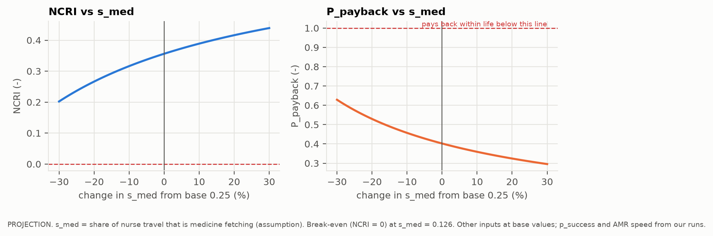 | 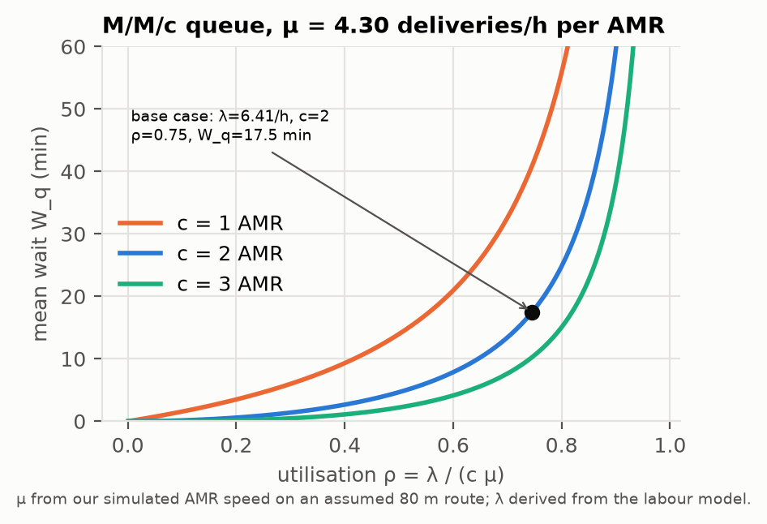

SECTION 4 · Simulation Telemetry, Monte Carlo Testing & Empirical Validation Component 1 · CDIO Robotics (10)
Evaluation protocol (titles sheet) | Conduct at least N = 50 automated simulated delivery runs across three corridor congestion layouts (Clear, Static Obstacles, Dynamic Walking Humans). Log transit latency (s), collision rate (%), trajectory smoothness (integrated jerk, m/s^3), and battery state-of-charge decay. Report Student's t-test comparing manual courier transit vs AMR transit time.
Telemetry standard | Log at 500 Hz (MJCF timestep 0.002 s, or every 2nd step at 0.001 s): time, state (q, q̇ or pose, velocity), reference, tracking error, actuator torques/forces, FSM state, events. One CSV per run or one CSV with a run_id column.
Monte Carlo | N ≥ 30 runs per condition (more if your protocol says so). Randomise disturbances and initial conditions from stated distributions; record every random seed.
Required measures | Tracking RMSE = √(Σ‖p − p_ref‖² / n) on the planned corridor path (x_ref(t), y_ref(t)) vs MuJoCo base position; control effort E = ∫τ² dt (sum of τ²·Δt over all actuators); your primary task metric from the protocol.
Statistics | Compare the proposed controller with a baseline condition: Student's / Welch's t-test (two-sided, α = 0.05), Cohen's d = (x̄₁ − x̄₂) / s_pooled, and a 95 % confidence interval.
Where real trial data goes | Group_01_Khushal_Priyal_Ishita_Sowmya/analytics/*_real_trials.csv, produced by your controller. Files named SIMULATED_* are starter targets, never results.
Owner | Telemetry QA Lead: E060.

Baseline condition you compare against | dwa-1.0 (handoff controller) on identical seeded scenarios (corrected generator, crowd model 1.1). Protocol t-test against the modelled manual courier is also reported.
Monte Carlo runs per condition (N) | N = 60 per condition: 3 layouts (Clear, Static, Dynamic) x 2 controllers = 360 runs, seeds 100-159; plus a 600-run validation matrix (results/validation)
Randomised parameters and their distributions | floor mu ~ U(0.55, 0.85); medicine mass ~ U(0.10, 0.50) kg; extra parked items U{0..3}, x ~ U(-3.5, 4.5) m; pedestrians (dynamic) K ~ U{3..8}, speed N(1.10, 0.25^2) clipped [0.6, 1.8] m/s, x ~ U(-10, 10), y ~ U(-0.8, 0.8) m, direction +/-1; lidar noise N(0, 0.01^2) m
Logging rate actually achieved (Hz) | 500.0 Hz (median; minimum 500.0 Hz): every mj_step at 0.002 s, logged from MuJoCo state
Random seeds recorded for every run | Yes
Real-trials CSV path(s) in the repo | Group_01_Khushal_Priyal_Ishita_Sowmya/analytics/icu_medicine_delivery_real_trials.csv (experiment = dossier_eval)

Measure | N | Baseline mean ± SD | Proposed mean ± SD | Unit | Better? (direction)
Tracking RMSE | 180 / 180 | 0.1649 ± 0.149 | 0.1669 ± 0.15 | m | Lower is better
Control effort ∫τ² dt | 180 / 180 | 13.32 ± 6.87 | 17.4 ± 14.1 | N^2 m^2 s | Lower is better
Transit latency (delivered runs, all layouts) | 168 / 172 delivered of 180 / 180 | 24.5 ± 11 | 30.5 ± 19.8 | s | Lower is better

Test used | Welch's t-test
t statistic, degrees of freedom, p-value (primary metric) | dwa-1.1 vs dwa-1.0: t = 3.48, df = 268.9, p = 0.00058. Protocol (Student's): AMR vs courier t = 10.99, df = 342, p = 2.9e-24
Cohen's d (primary metric) | d = 0.38 (proposed slower); AMR vs courier d = 1.19
95 % confidence interval of the difference | [2.6, 9.4] s (proposed - baseline); AMR - courier [14.8, 21.3] s. Collisions 7 -> 0 of 180

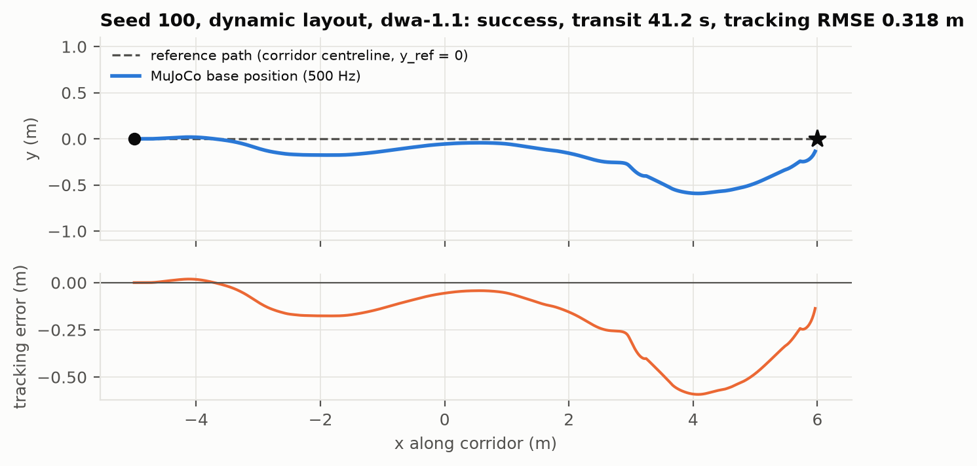 | 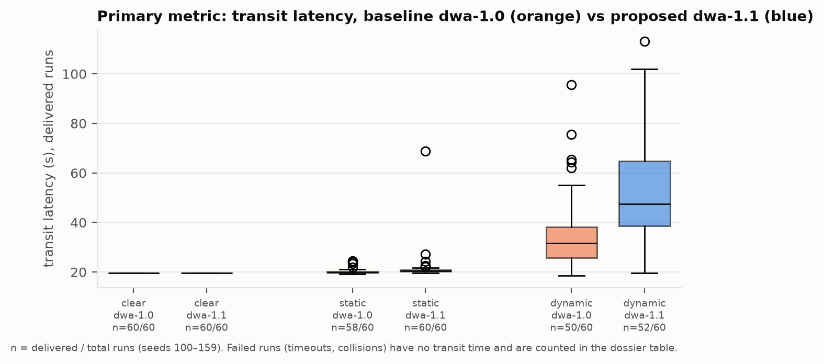

DATA PROVENANCE DECLARATION (mandatory). Reporting generated target numbers as experimental results is research misconduct and scores zero for this component.
Every number in Section 4 comes from MuJoCo runs of OUR controller, logged by our code | Yes
No value comes from SIMULATED_* files, generate_paper_figures.py or any np.random 'target' data | Yes
Our plots re-generate from the *_real_trials.csv files in the repo | Yes
Every input in Section 3 has a source or is labelled as an assumption | Yes

SECTION 5 · LinkedIn Video Showcase, AI Verification Audit & Peer Review Component 3 · Showcase & Viva (5)
LinkedIn post URL | type here
Video length (mm:ss) | type here
Video shows the live MuJoCo simulation (not slides) | Select ▾
Video shows our business sensitivity graph | Select ▾
Webcam picture-in-picture: every member appears and speaks | Select ▾

5.1 AI Interaction Audit Log: three cases where AI gave wrong robotics or economic data
Examples: a wrong MuJoCo attribute or API call, an invented statistic, a correct paper given the wrong journal, an economic formula with the wrong units. Show how you checked each one with a textbook, the official documentation or the original paper.
# | AI tool | What we asked & what AI said | How we caught it | What was actually true (with source) | Error type | Verdict
AI-01 | Claude | Asked for the RN wage as a labour-cost basis; it recalled a median of $86,070/yr. (Later superseded: the 3.1 model is dimensionless and no longer uses a wage.) | Checked the original source | US BLS Occupational Outlook Handbook, Registered Nurses: median $97,550/yr ($46.90/h), May 2025. The recalled value was out of date. | Wrong number or statistic | Corrected
AI-02 | Claude | Proposed lowering safety inflation 0.12 -> 0.03 m for 'provably static' lidar points, assuming they are equipment, to pass a 0.80 m gap. | Ran / tested the code or simulation | Ground-truth pedestrian logs showed the 'static' points were standing people. Dev runs: 13/20 -> 10/20 delivered, plus a pedestrian contact. Fix rejected (backups/rejected_fixes). | Other | Rejected
AI-03 | Claude | Diagnosed baseline wall collisions as coming from the merged threshold in plan(), and said a wall check there would remove them. | Ran / tested the code or simulation | 500 Hz telemetry showed contacts in RECOVER and the fallback branch (dev seeds 8/11/19). The wall rule was extended there; validation collisions 7 -> 0/60. | Wrong code / MuJoCo API | Corrected

5.2 Peer review: watch both assigned LinkedIn videos and score them (0–2 per criterion)
Group reviewed | Problem | Physics | Business | Data | Clarity | Best moment (mm:ss) | One question for the viva
Group 02: AI Companion Robot for Remote Elderly Supervision & Fall Emergency Response | 2 | 2 | 2 | 2 | 2 | type here | type here
Group 07: Autonomous Mobile Manipulator for Hospital Housekeeping & Patient-Room Clutter Clearing | 2 | 2 | 2 | 2 | 2 | type here | type here

SECTION 6 · Individual Learning Record & Research Consent unmarked · one row per member · answer honestly
These answers do not change your marks. They help improve the course and are used in anonymised research only if you consent in the sign-off below. Commit share: your commits ÷ the group's commits in your folder (git shortlog -sn -- <folder>).
Member | Hours I spent (total) | My declared role matched my actual work (1 = not at all, 5 = fully) | I learned a skill outside my role (robotics ↔ business) | Scripts I mainly wrote (file names) | My commit share (%) | Share of my writing first drafted with AI | Wrong AI facts / code I personally caught
Khushal Asnani (E006) | 50 | 5 | Yes | type here | type here | 51–75 % | 1–2
Priyal Kaushal Deputy (E016) | 50 | 5 | Yes | type here | type here | 51–75 % | 1–2
Ishita Ranjan (E054) | 50 | 5 | Yes | type here | type here | 51–75 % | 1–2
Sowmya Satish (E060) | 50 | 5 | Yes | type here | type here | 51–75 % | 1–2

Member | Before this course I had used a physics simulator | The most valuable thing I learned (one line) | One thing I would change in this course (one line)
Khushal Asnani (E006) | Yes | type here | type here
Priyal Kaushal Deputy (E016) | Yes | type here | type here
Ishita Ranjan (E054) | Yes | type here | type here
Sowmya Satish (E060) | Yes | type here | type here

Track A: how this dossier becomes your 4-page IEEE paper
I. Introduction | Section 1: title, verified baseline friction, governing standards
II. Related work | Section 1.1: verified sources only (5+ with DOIs)
III. System model | Section 2: MJCF model, FSM, equations, control law
IV. Techno-economics & evaluation | Sections 3–4: CSBS model, FMEA, Monte Carlo results, statistics
V. Discussion & limitations | Sim-to-real gap, assumptions in the business model, AI audit lessons
Target venues (titles sheet) | A: AIR · B: IEEE CASE

Individual Academic Sign-off every member answers and signs
Answer each statement for yourself: (1) this work is original and every source and AI use is declared; (2) our model loads and our controller and business scripts run from the repository; (3) I understand our whole project and can explain my own part in the viva voce.
Member (Roll) | (1) Original work | (2) Code runs | (3) Viva-ready | Signature | Optional research consent*
Khushal Asnani (E006) | Yes | Yes | Yes |  | Yes
Priyal Kaushal Deputy (E016) | Yes | Yes | Yes |  | Yes
Ishita Ranjan (E054) | Yes | Yes | Yes | 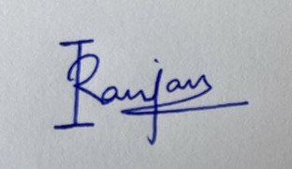 | Yes
Sowmya Satish (E060) | Yes | Yes | Yes | 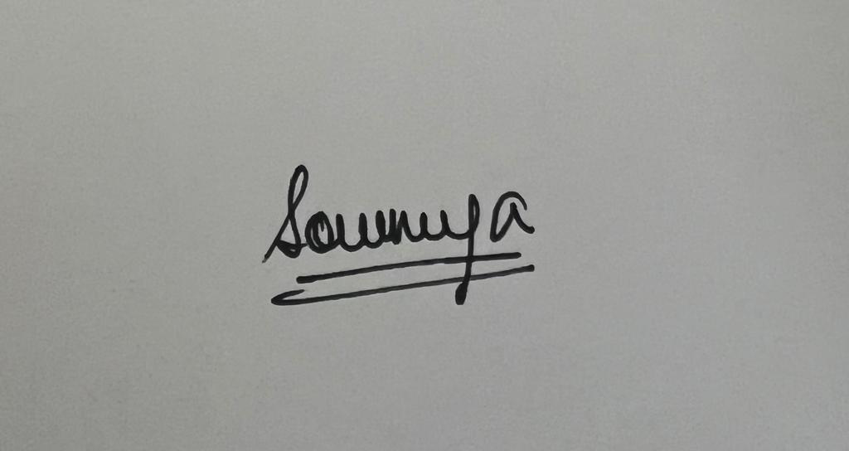 | Yes
*Optional: may Dr. Nanade use anonymised data from this dossier and repository in education research publications? Your answer has no effect on your marks, and you can withdraw until results are published.

